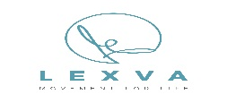Enrolment Form and Participant Agreement
Please take your time to fill out the following as accurately as possible.
PERSONAL INFORMATION
Full Name
Contact #’s | (m) (h) (w)
Address
Email
Occupation
Birthdate
EMERGENCY CONTACT
Name
Contact #
HEALTH & FITNESS
Do you have any injuries?
Are you pregnant or have you had a baby in the last 6mnths?
Are you currently taking any medication?
Do you have a heart condition or any undiagnosed chest pain?
Do you have confirmed high or low blood pressure?
Have you had any corrective joint surgeries in the last 12 months?
Are you on an orthopaedic waiting list?
Do you take part in other physical activities?
Do you have any fitness/health goals?
I understand the various risks associated with an exercise programme & it is my desire to participate. I have read the terms & conditions & understand the rules, regulations and policies.
I HAVE READ, UNDERSTOOD AND ACCURATELY COMPLETED THIS QUESTIONNAIRE AND ACCEPT THE LEXVA POLICIES.

SIGNATURE: | DATE:
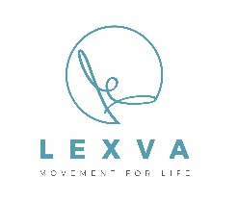
Contract Terms & Conditions
All services purchased from LEXVA Movement for Life will be preceded by the applicant acknowledging, by way of completing a health assessment form, that he/she has no physical limitations preventing him/her from participation. All applicants under the age of 18 years must have consent, in written form, from a parent or guardian. The applicant also agrees to abide by the rules and regulations of the classes/services and acknowledges that these rules and regulations may change from time to time.
LEXVA Movement for life will compensate for any loss or damage suffered if we fail to carry out our obligations under this agreement, or to a reasonable standard, or breach any duties imposed on us by law unless that failure is attributable to:
(i) your own fault;
(ii) a third party unconnected with our provision of services under this agreement; or
(iii) events which neither we nor our suppliers could have foreseen or forestalled even if we had taken all reasonable care.
Any lost property handed-in will be retained by staff and should be claimed within a 2week period.
If we terminate your agreement for any serious reason, we reserve the right to retain a proportion of the money which you have paid to us under this agreement to cover any reasonable costs that we have incurred as a result.
As a customer you agree to comply with the rules of the studio/clinic relating to opening hours, use of the facilities and conduct. We may make reasonable changes to these rules at any time provided we give advance notice of the changes.
Details of our current classes and Physiotherapy/Massage services are displayed on our website www.lexva.co.uk face book page. We may sometimes need to change opening hours, the schedule of classes or facilities/ services available. If we need to do this we will, where reasonably possible, display notices and/or update our face book page notifying you of the change at least 1 week beforehand. If we make significant changes to the opening hours or facilities available, you can cancel your agreement and we will refund you for any part of your fee for the period since the change was in force.

